**ANALYSIS REPORT:**

**1.KMEANS:**

**BEFORE PREPROCESSING:**

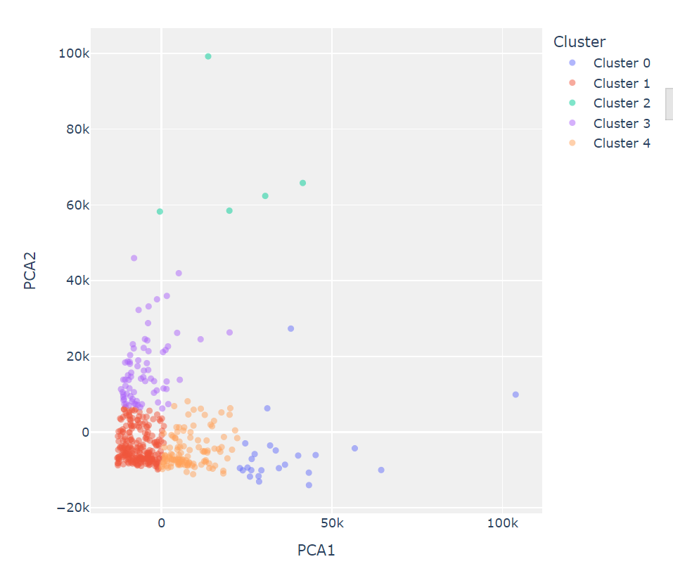

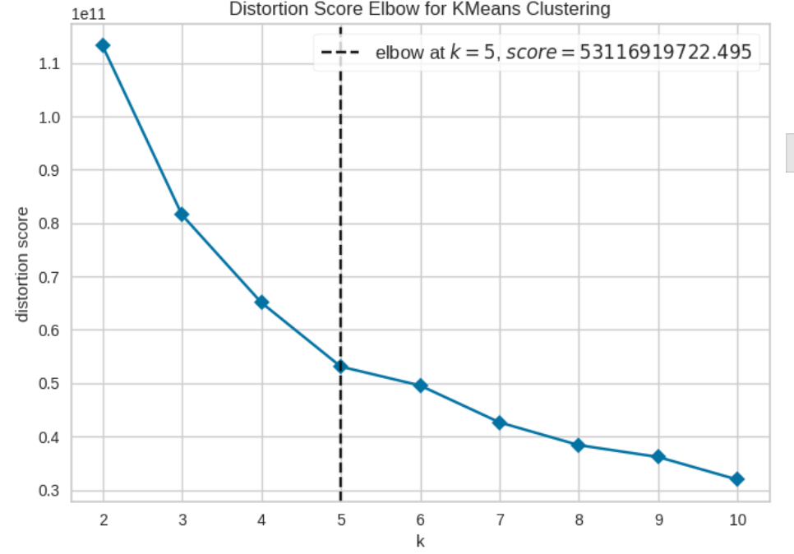

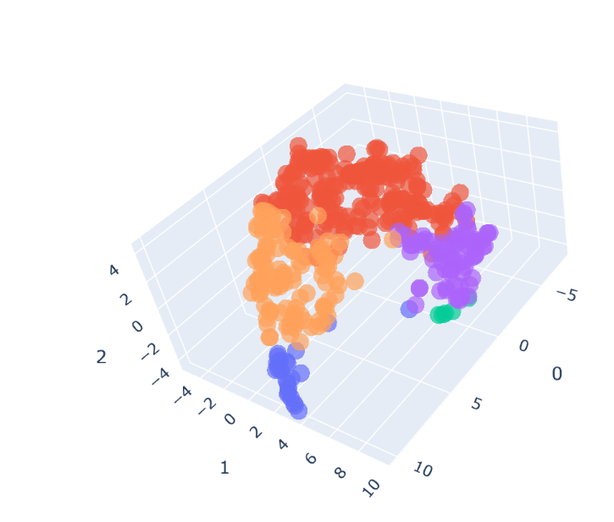

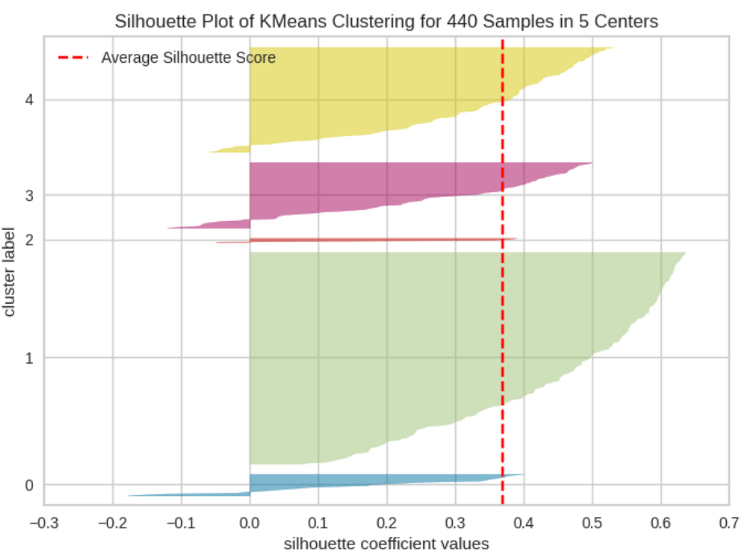

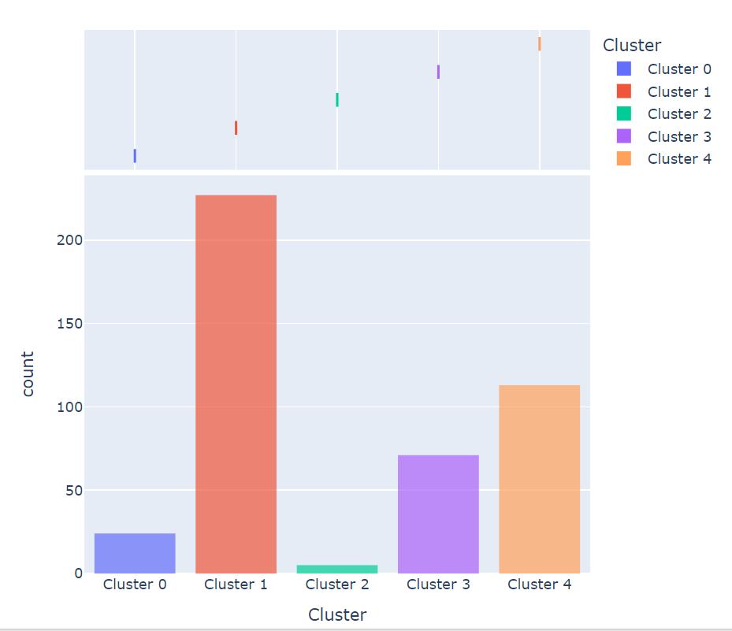

**AFTER PRE PROCESSING:**

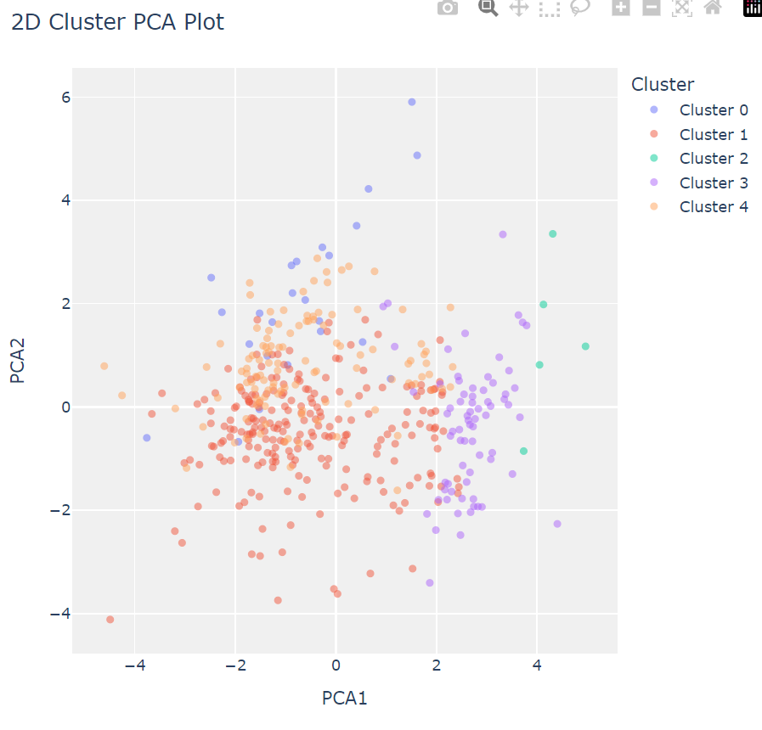

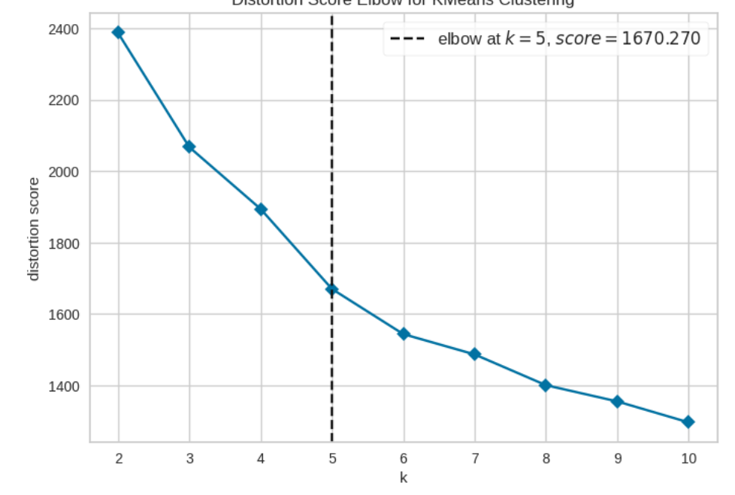

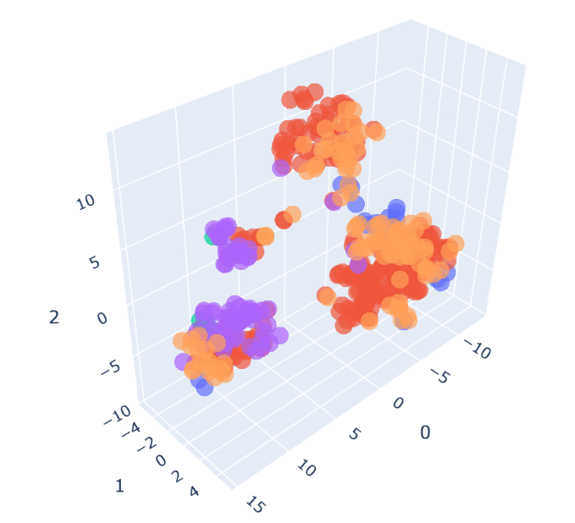

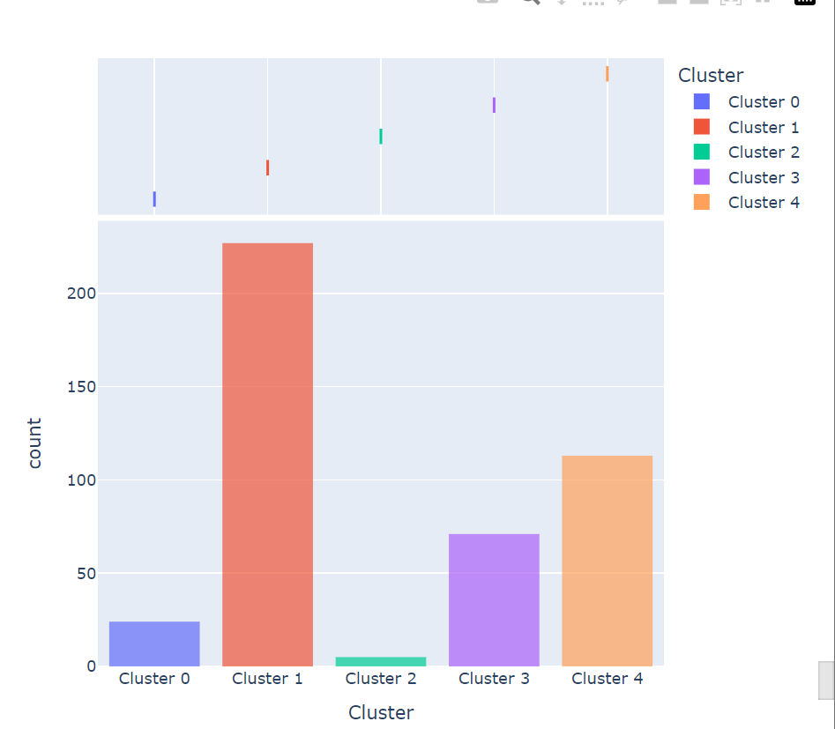

**RESULT:**

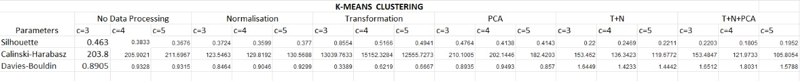

**2. HIERARCHICAL:**

**BEFORE PROCESSING:**

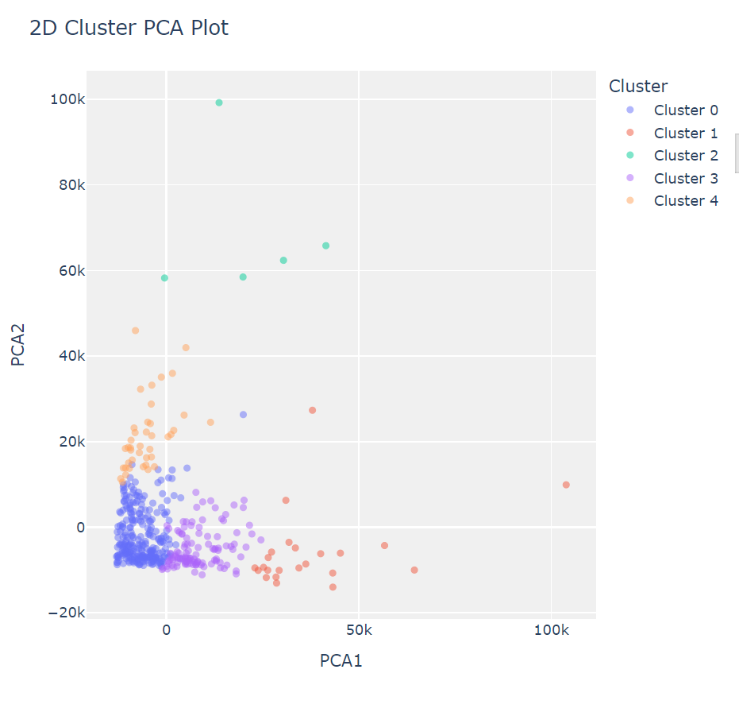

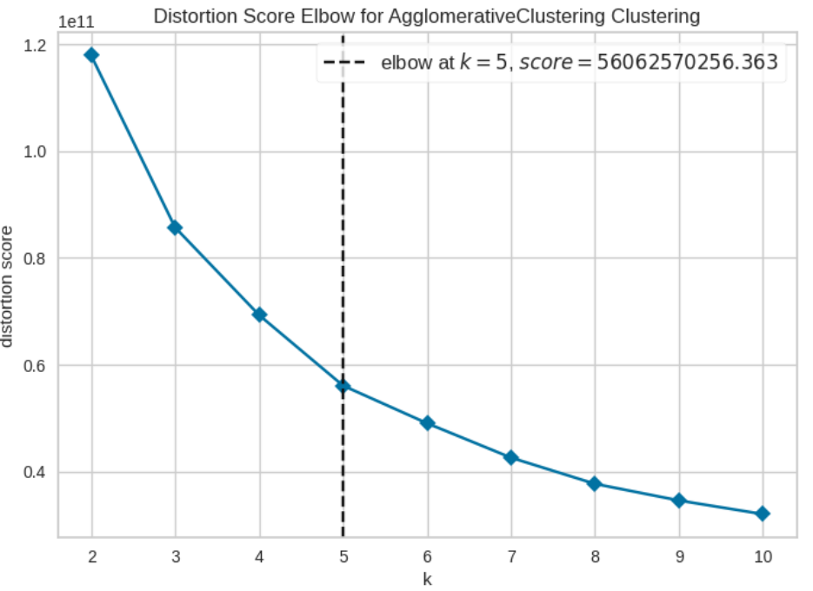

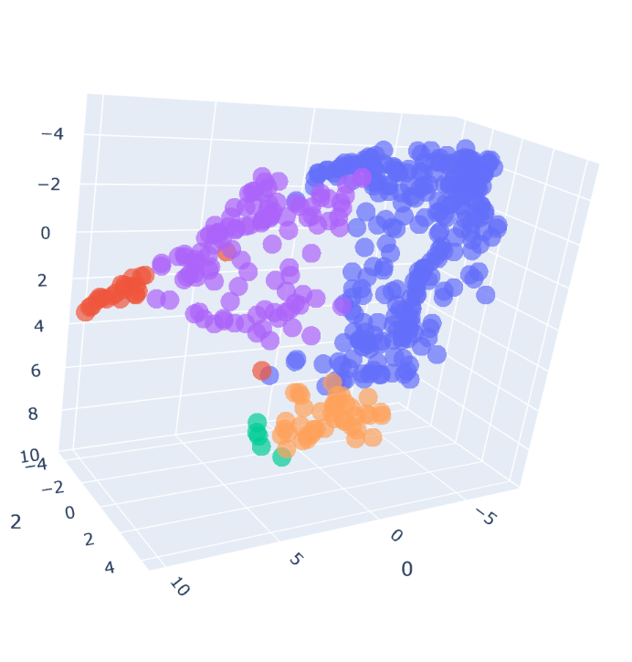

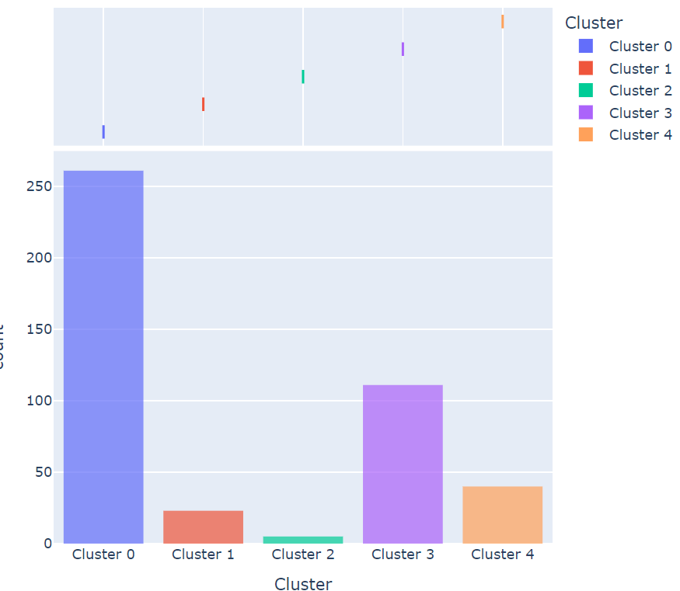

**AFTER PROCESSING:**

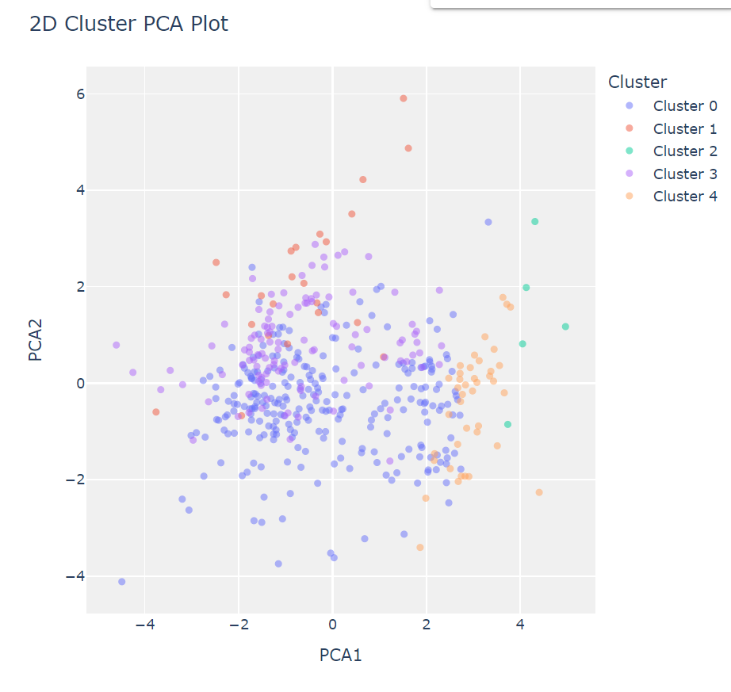

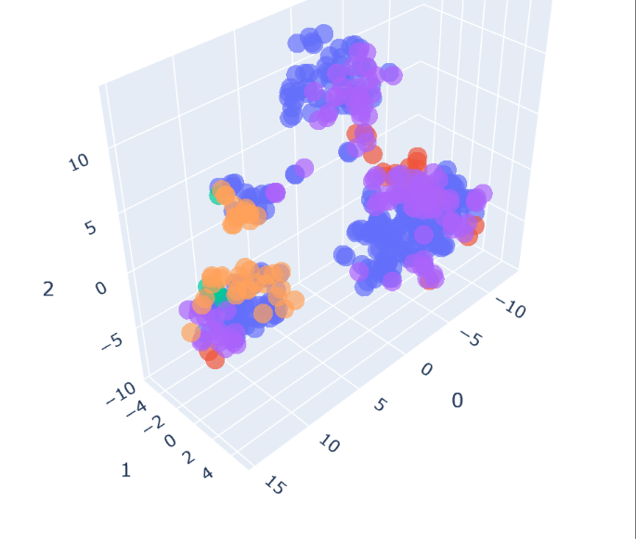

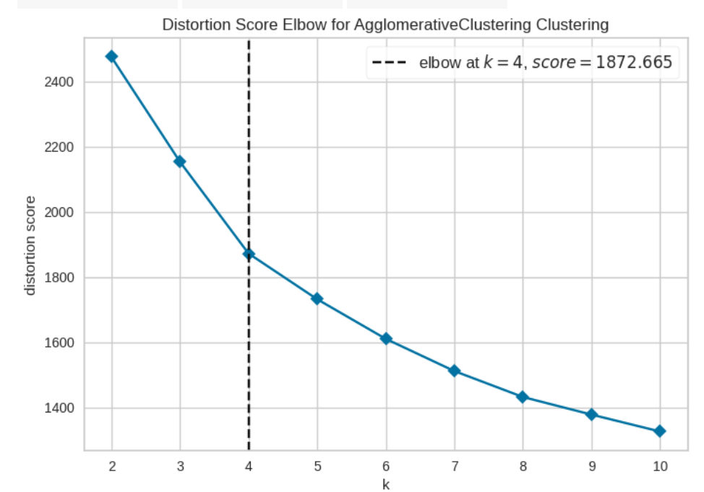

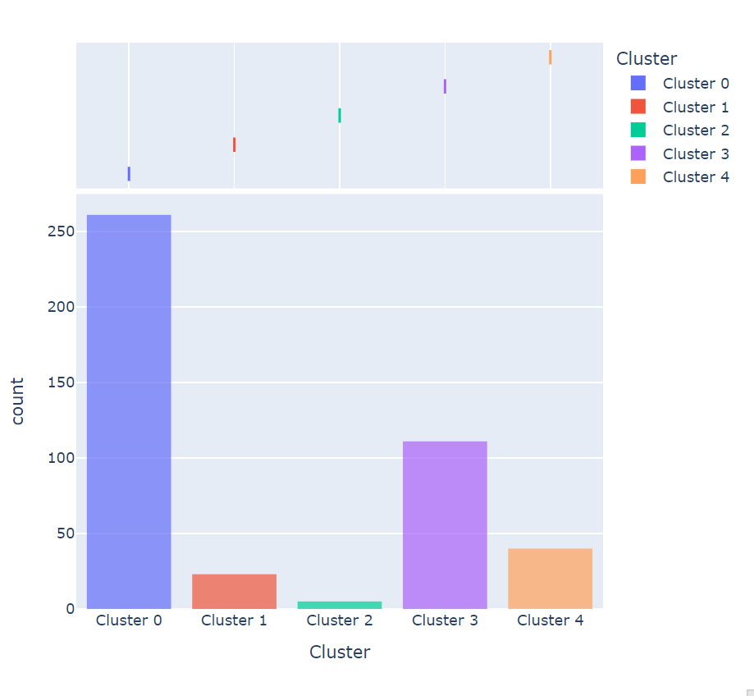

**RESULT:**

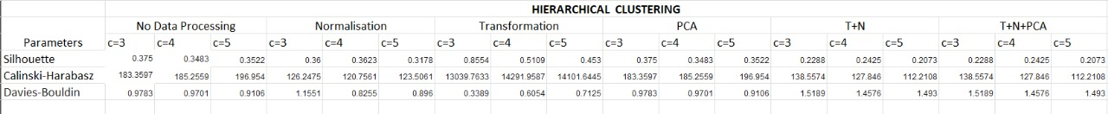

**3. MEAN SHIFTING:**

**BEFORE PROCESSING:**

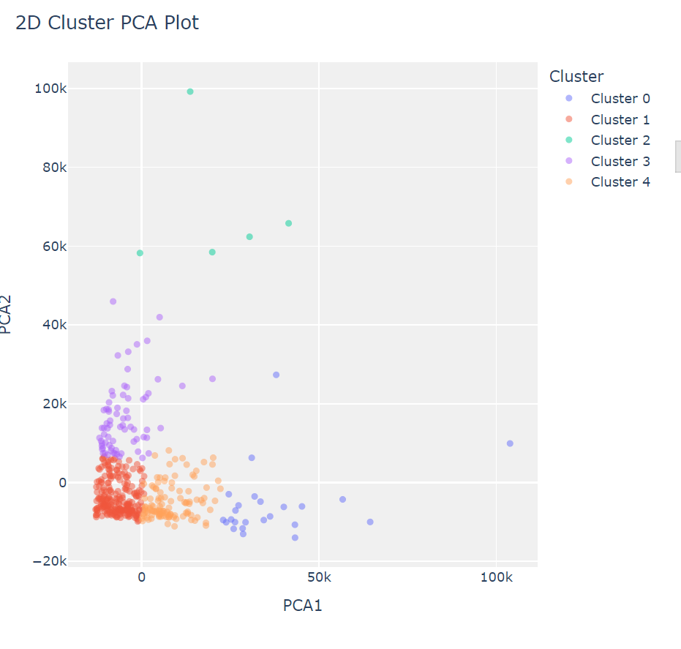

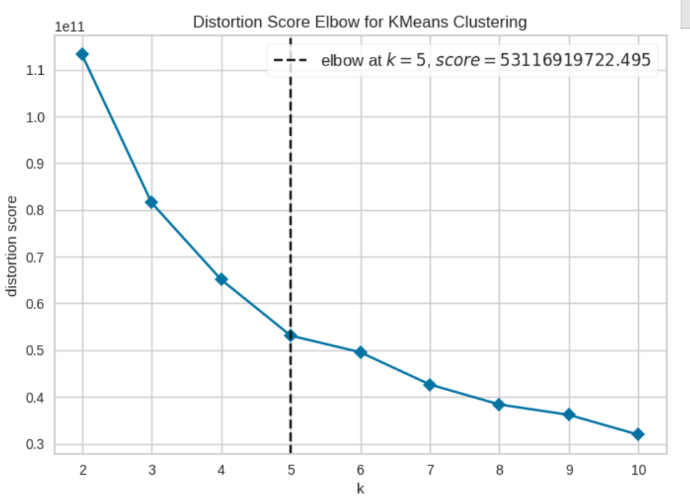

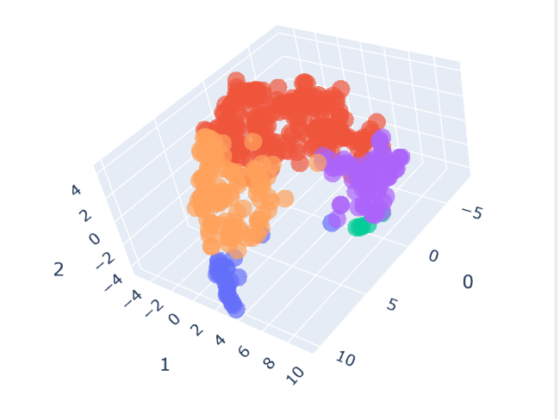

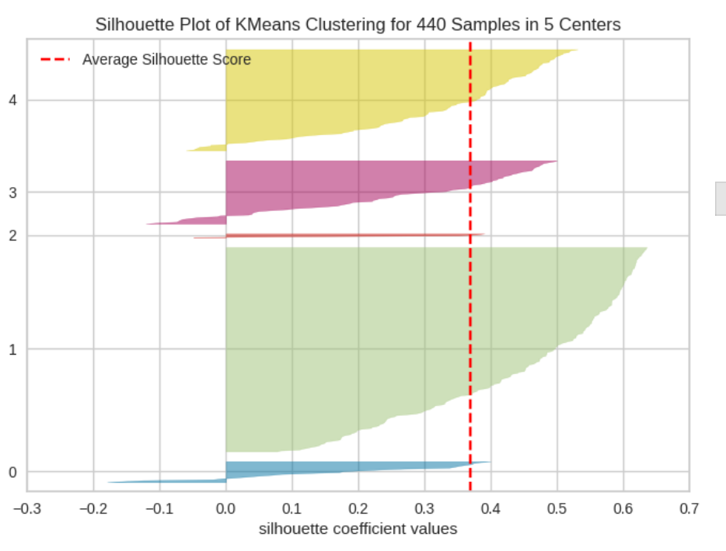

**AFTER PROCESSING:**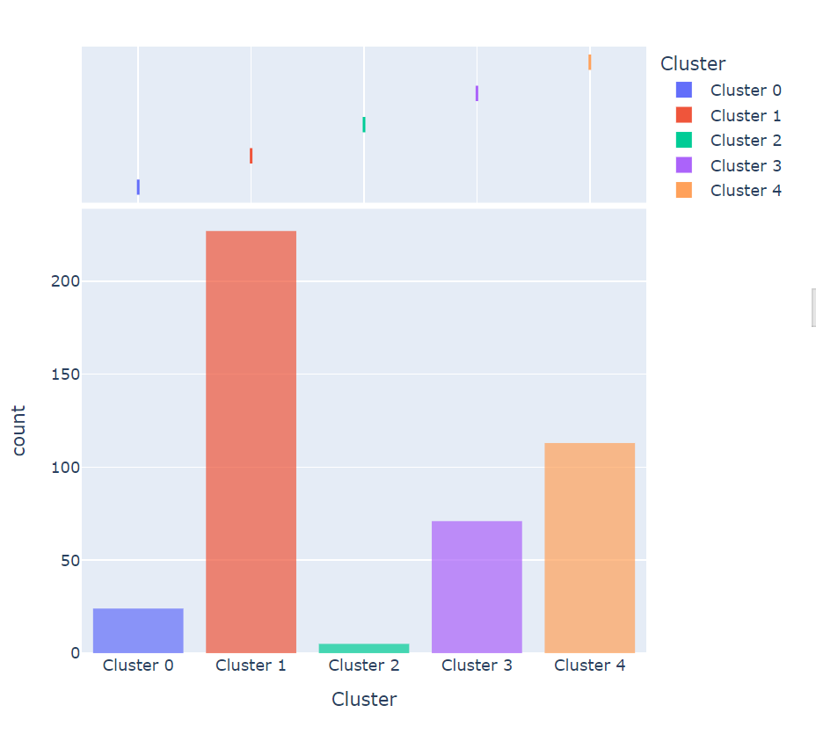

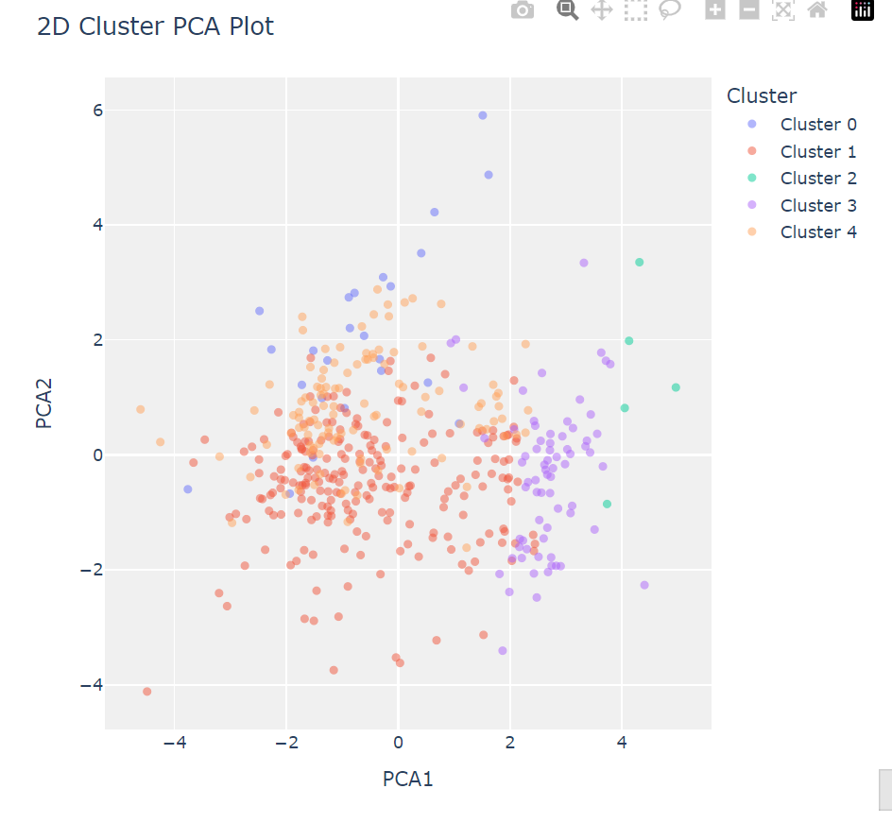

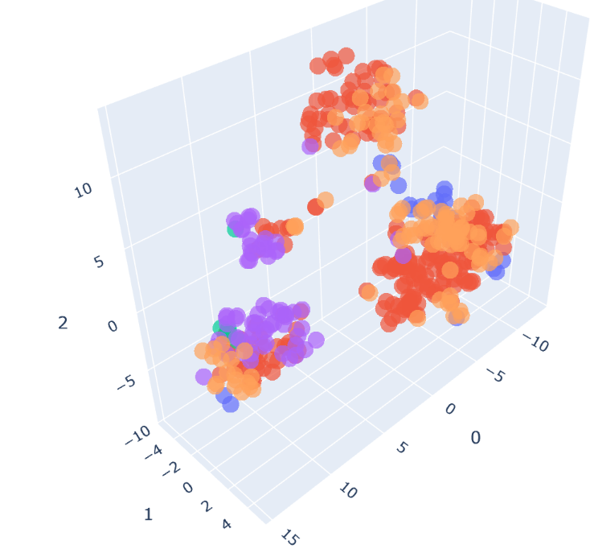

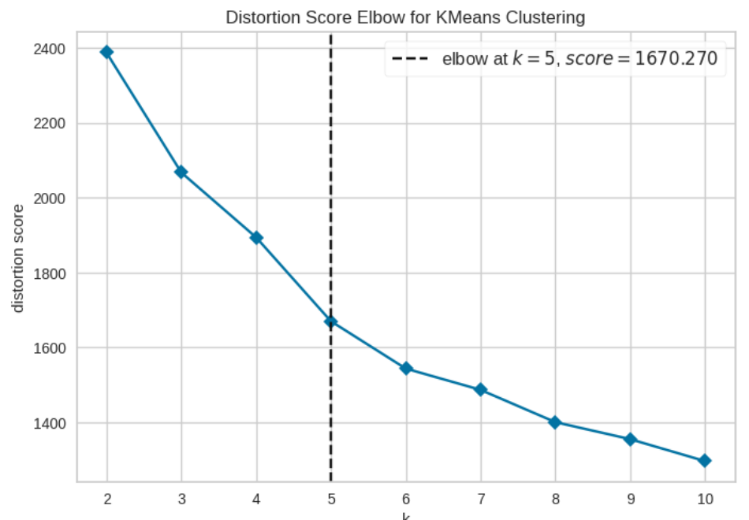

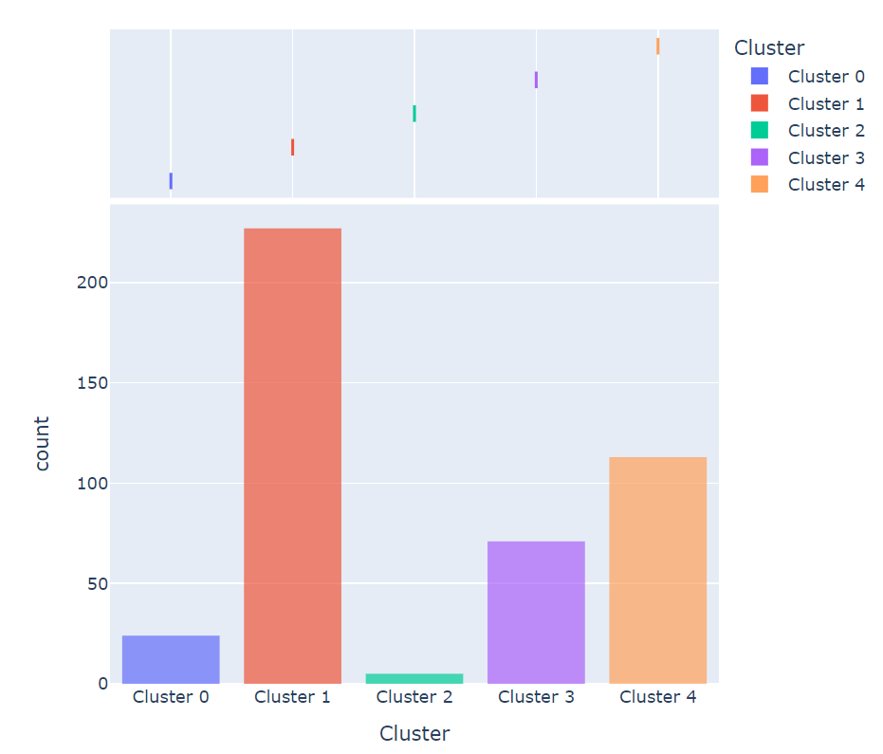

**RESULT:**

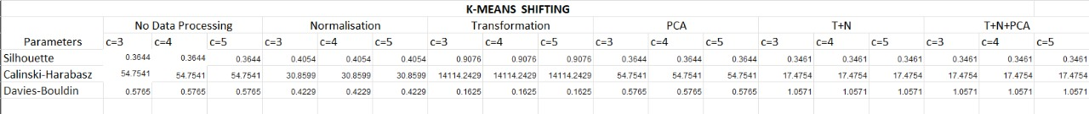

**Detailed Insights from graphs:**

**1. Hierarchical Clustering (HClust)**

* **Graphs Observed:** Dendrograms before and after preprocessing.
* **Performance:**
  + Preprocessing slightly improved cluster separability, but the method struggled with larger datasets, as clusters appeared elongated and overlapping in some cases.
  + Dendrograms provided a hierarchical view, but it was challenging to define the exact number of clusters.

**2. K-Means Clustering**

* **Graphs Observed:** Elbow method, scatterplots, and silhouette score.
* **Performance:**
  + Preprocessing drastically improved clustering results, showing well-separated and compact clusters.
  + The Elbow method indicated an optimal cluster count (e.g., K=4).
  + Silhouette scores were higher than HClust, confirming well-defined clusters.

**3. Mean Shift Clustering**

* **Graphs Observed:** Density-based scatterplots showing cluster boundaries.
* **Performance:**
  + Successfully captured clusters of varying shapes and densities.
  + However, the choice of bandwidth parameter affected the results, and excessive noise caused some clusters to merge.
  + Visualization highlighted its ability to handle non-linear clusters but lacked scalability for larger datasets.

**Conclusion:**

**K-Means performed the best overall** for structured datasets after preprocessing. It showed:

* Clear and compact clusters.
* High silhouette scores, indicating good intra-cluster cohesion and inter-cluster separation.
* The scalability to handle larger datasets effectively.